Project

Office Network Using Cisco Packet Tracer

Abhinav Malhotra

INTRODUCTION

This projects is build using Cisco Packet Tracer demonstrate a implementation of a wired and wireless network in a new rented office space with following departments:

- IT - 2 machines
- Sales -10 machines
- Finance - 20 machines
- Marketing - 15 machines
- Human Resources -10 machines
- Wireless Internal - 40 ip address
- Wireless Guest - 50 ip address

Assigned Address: 172.16.4.0/23 All the segmentations and assignment of ip address where done keeping in the needs of each departments. All the subnets with the ip address range are shown in the table below.

Subnetting Table :
Subnet | SubnetMask | Network Address | Broadcast Address | Assignable Range | Vlans | Usable Hosts
172.16.4.0 /28 | 255.255.255.240 | 172.16.4.0 | 172.16.4.15 | 172.16.4.1-172.16.4.14 |  | 14
172.16.4.16 /28 | 255.255.255.240 | 172.16.4.16 | 172.16.4.31 | 172.16.4.17-172.16.4.30 | IT(20) | 14
172.16.4.32 /27 | 255.255.255.224 | 172.16.4.32 | 172.16.4.63 | 172.16.4.33-172.16.4.62 | Finance(40) | 30
172.16.4.64 /27 | 255.255.255.224 | 172.16.4.64 | 172.16.4.95 | 172.16.4.65-172.16.4.94 | Sales(30) | 30
172.16.4.96 /27 | 255.255.255.224 | 172.16.4.96 | 172.16.4.127 | 172.16.4.97-172.16.4.126 | HumanRes(60) | 30
172.16.4.128 /27 | 255.255.255.224 | 172.16.4.128 | 172.16.4.159 | 172.16.4.129-172.16.4.158 | Marketing(50) | 30
172.16.5.1 /28 | 255.255.255.240 | 172.16.5.0 | 172.16.5.16 | 172.16.5.1-172.16.5.14 | Servers(70) | 14
172.16.4.192 /26 | 255.255.255.192 | 172.16.4.192 | 172.16.4.255 | 172.16.4.193-172.16.4.254 | WirelessInternal(80) | 62
172.16.5.64 /26 | 255.255.255.192 | 172.16.5.64 | 172.16.5.127 | 172.16.5.65-172.16.5.126 | WIrelessGuest(90) | 62

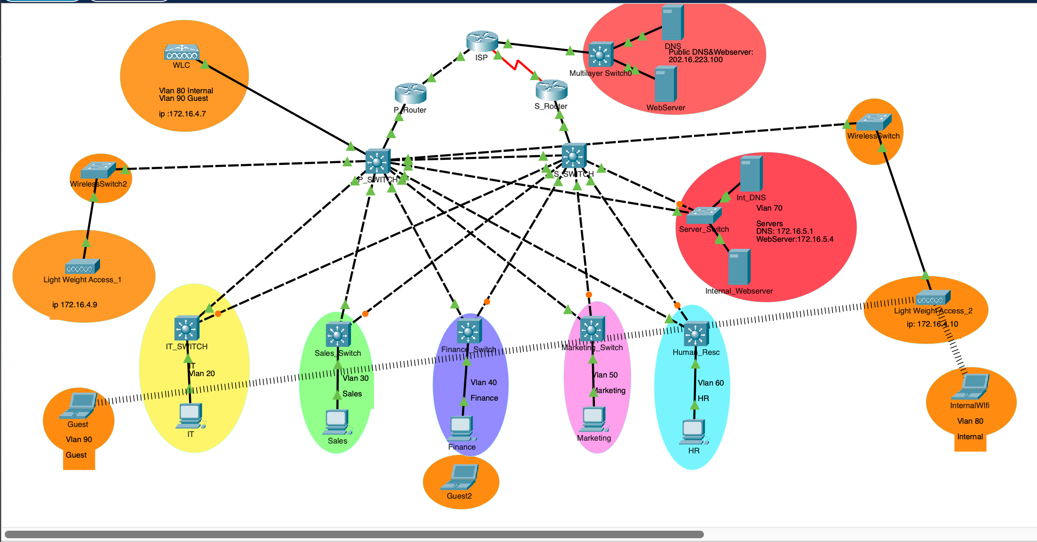
Network Diagram:

Vlan Summary

IT : Vlan 20 Vlan name IT

Subnet: 172.16.4.16 /28 Subnet Mask : 255.255.255.240

IP Range : 172.16.4.17-172.16.4.30

Default Gateways: 172.16.4.17 , 172.16.4.18

Device | Static Ip address
Primary Router(P_Router) | 172.16.4.17
Secondary Router(S_Router | 172.16.4.18
HSRP | 172.16.4.19

Sales: Vlan 30 Vlan name sales

Subnet: 172.16.4.64 /27 Subnet Mask: 255.255.255.224

IP Range: 172.16.4.65-172.16.4.94

Default Gateways: 172.16.4.65, 172.16.4.66
Device | Static Ip address
Primary Router(P_router) | 172.16.4.65
Secondary Router(S_router) | 172.16.4.66
HSRP | 172.16.4.67

Finance: Vlan 40, Vlan name finance

Subnet: 172.16.4.32 /27 Subnet Mask: 255.255.255.224

IP Range: 172.16.4.33-172.16.4.62

Default Gateways: 172.16.4.33, 172.16.4.34
Device | Static ip address
Primary Router(P_router) | 172.16.4.33
Secondary Router(S_router) | 172.16.4.34
HSRP | 172.16.4.35

Marketing: Vlan 50, Vlan name marketing

Subnet: 172.16.4.128 /27 Subnet Mask : 255.255.255.224

IP Range: 172.16.4.129-172.16.4.158

Default Gateways: 172.16.4.129, 172.16.4.130
Device | Static ip address
Primary Router(P_router) | 172.16.4.129
Secondary Router(S_router) | 172.16.4.130
HSRP | 172.16.4.131

Human Resources: Vlan 60, Vlan name HumanResc

Subnet: 172.16.4.96 /27 Subnet Mask: 255.255.255.224

IP Range: 172.16.4.97-172.16.4.126

Default Gateways: 172.16.4.97, 172.16.4.98
Device | Static Ip address
Primary Router(P_router) | 172.16.4.97
Secondary Router(S_router) | 172.16.4.98
HSRP | 172.16.4.99

Servers: Vlan 70, Vlan name Servers

Subnet: 172.16.5.0 /28 SubnetMask: 255.255.255.240

IP Range: 172.16.5.1-172.16.5.14

Default Gateways:
Device | Static Ip address
Primary Router(P_router) | 172.16.5.1
Secondary Router(S_router) | 172.16.5.3
DNS(Internal DNS) | 172.16.5.2
Webserver(internal Webservers) | 172.16.5.4

Wirless Internal: Vlan 80 name wirelessInternal

Subnet: 172.16.4.192 /26 Subnet mask: 255.255.255.192

IP Range: 172.16.4.193-172.16.4.254

Default Gateways: 172.16.4.193
Wlan | Ip address
InternalWifi | 172.16.4.196

Wireless Guest: Vlan 90 name wirelessGuest

Subnet: 172.16.5.64 /26 Subnet mask: 255.255.255.192

Ip range: 172.16.5.65-172.16.5.126

Default Gateways: 172.16.5.65

Wlan | Ip address
GuestWifi | 172.16.5.68

Infrastructure: vlan 1 , name default

Subnet: 172.16.4.0 /28 Subnet mask: 255.255.255.240

Ip range: 172.16.4.1 - 172.16.4.15

Default Gateways: 172.16.4.1 , 172.16.4.2
Deivces | Static Ip address
Primary Router(P_router) | 172.16.4.1
Secondary Router(S_router) | 172.16.4.2
Wireless Controller(WLC) | 172.16.4.7
Access Point 1 | 172.16.4.9
Access Point 2 | 172.16.4.10
Primary Switch(P_Switch) | 172.16.4.4
Secondary Switch(S_Switch) | 172.16.4.5

ISP: 30.0.0.0 /28

IP Route 0.0.0.0 0.0.0.0 G0/0/0

Subnet For Router 1 30.0.0.0 /29

IP range: 30.0.0.1 - 30.0.0.7

Subnet for Secondary Router 30.0.0.7 /29

IP range: 30.0.0.9 30.0.0.14
Device | Interface | IP Address Static
ISP | G0/0/1 | 30.0.0.1
 | S0/1/0 | 30.0.0.9
Primary Router | G0/0/0 | 172.16.4.1
 | G0/0/1 | 30.0.0.2
Secondary Router | G0/0/1 | 172.16.4.2
 | S0/1/0 | 30.0.0.10
WebServer |  | 202.16.223.100

DHCP
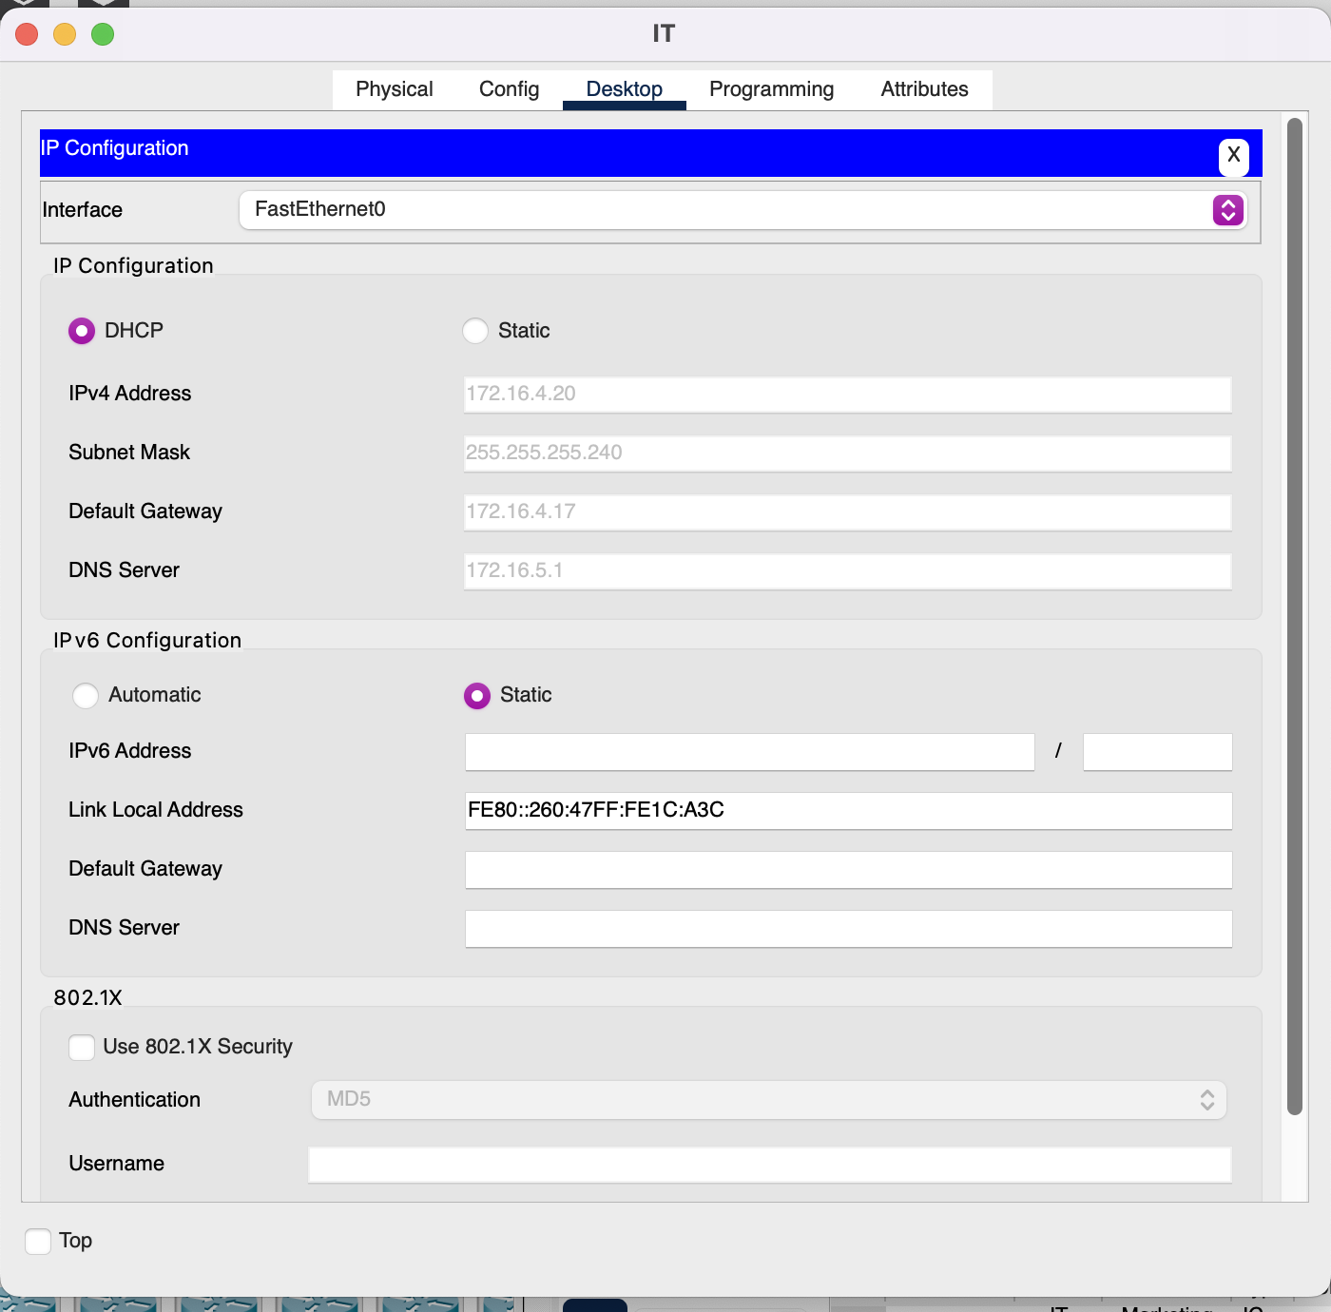

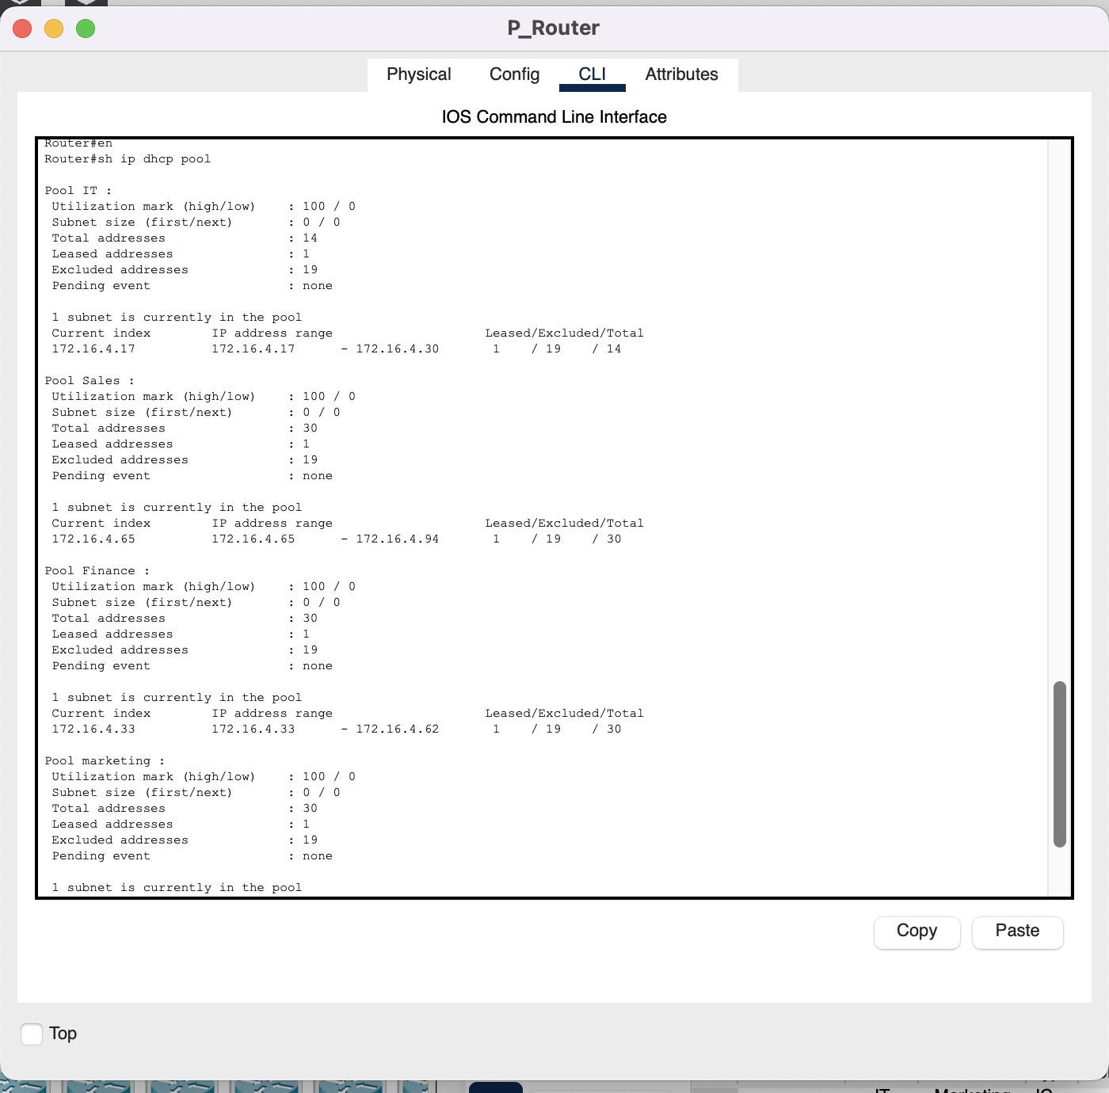

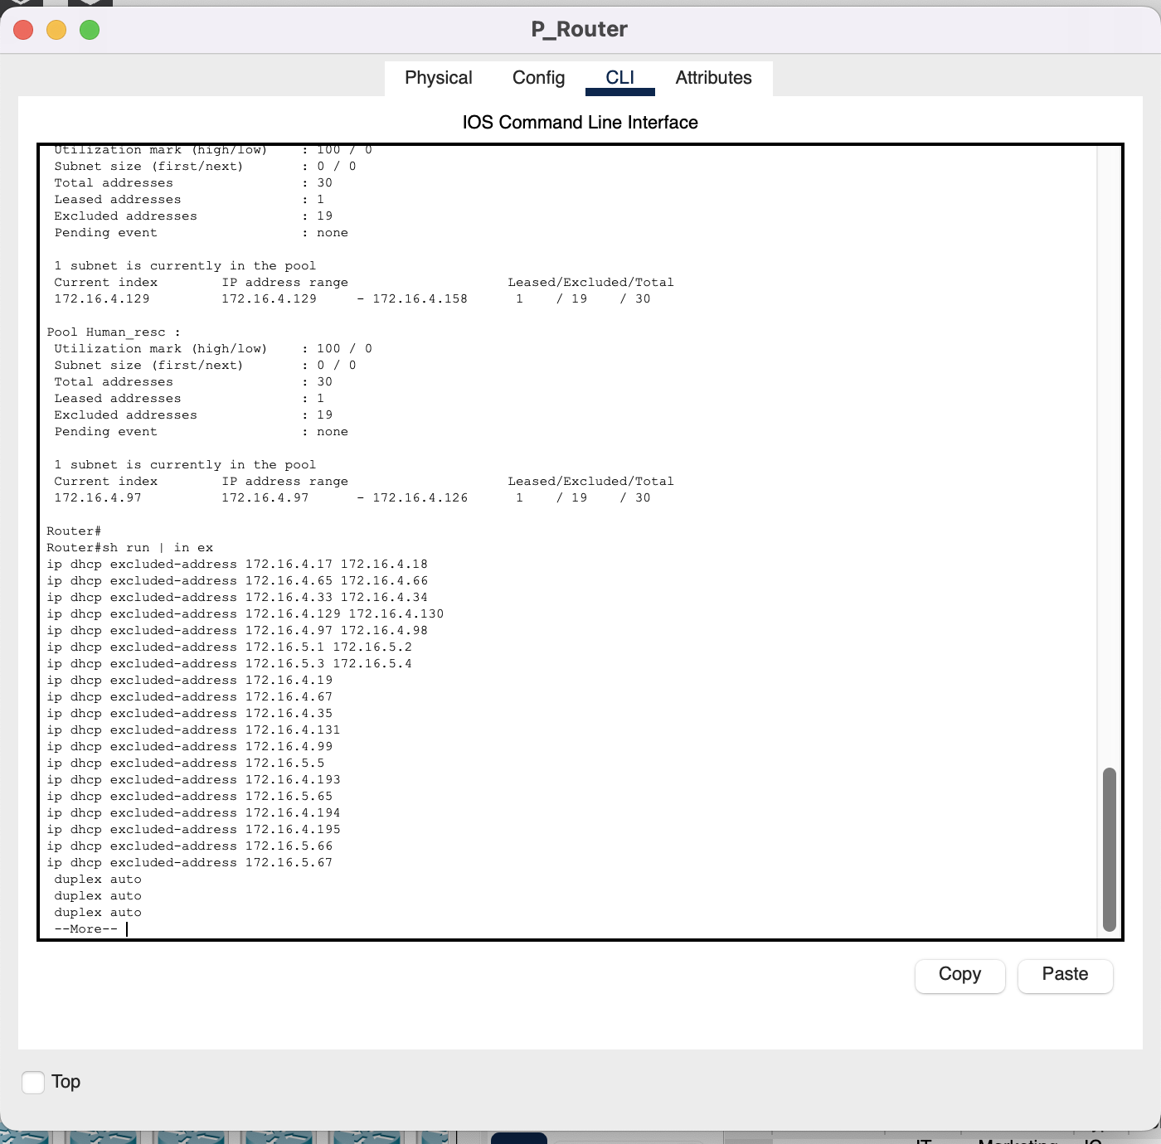
DHCP Excluded Addresses:

Spanning Tree:

Primary Switch:
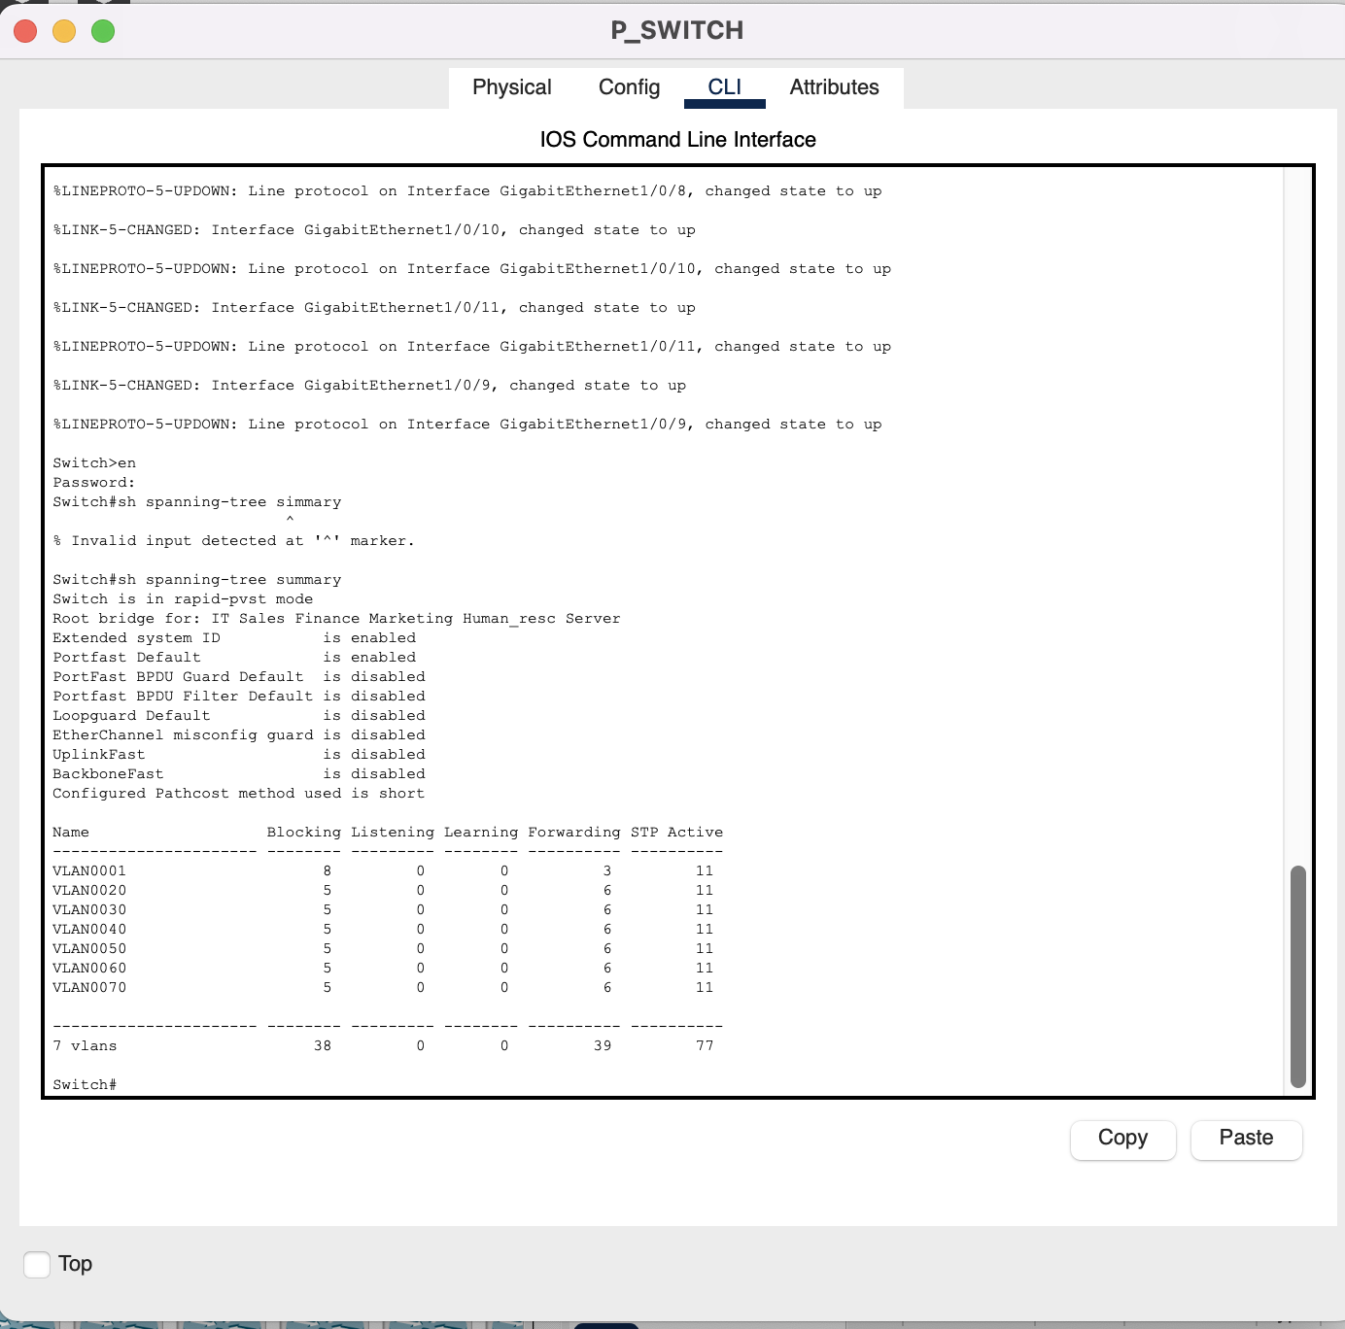

Secondary Switch:
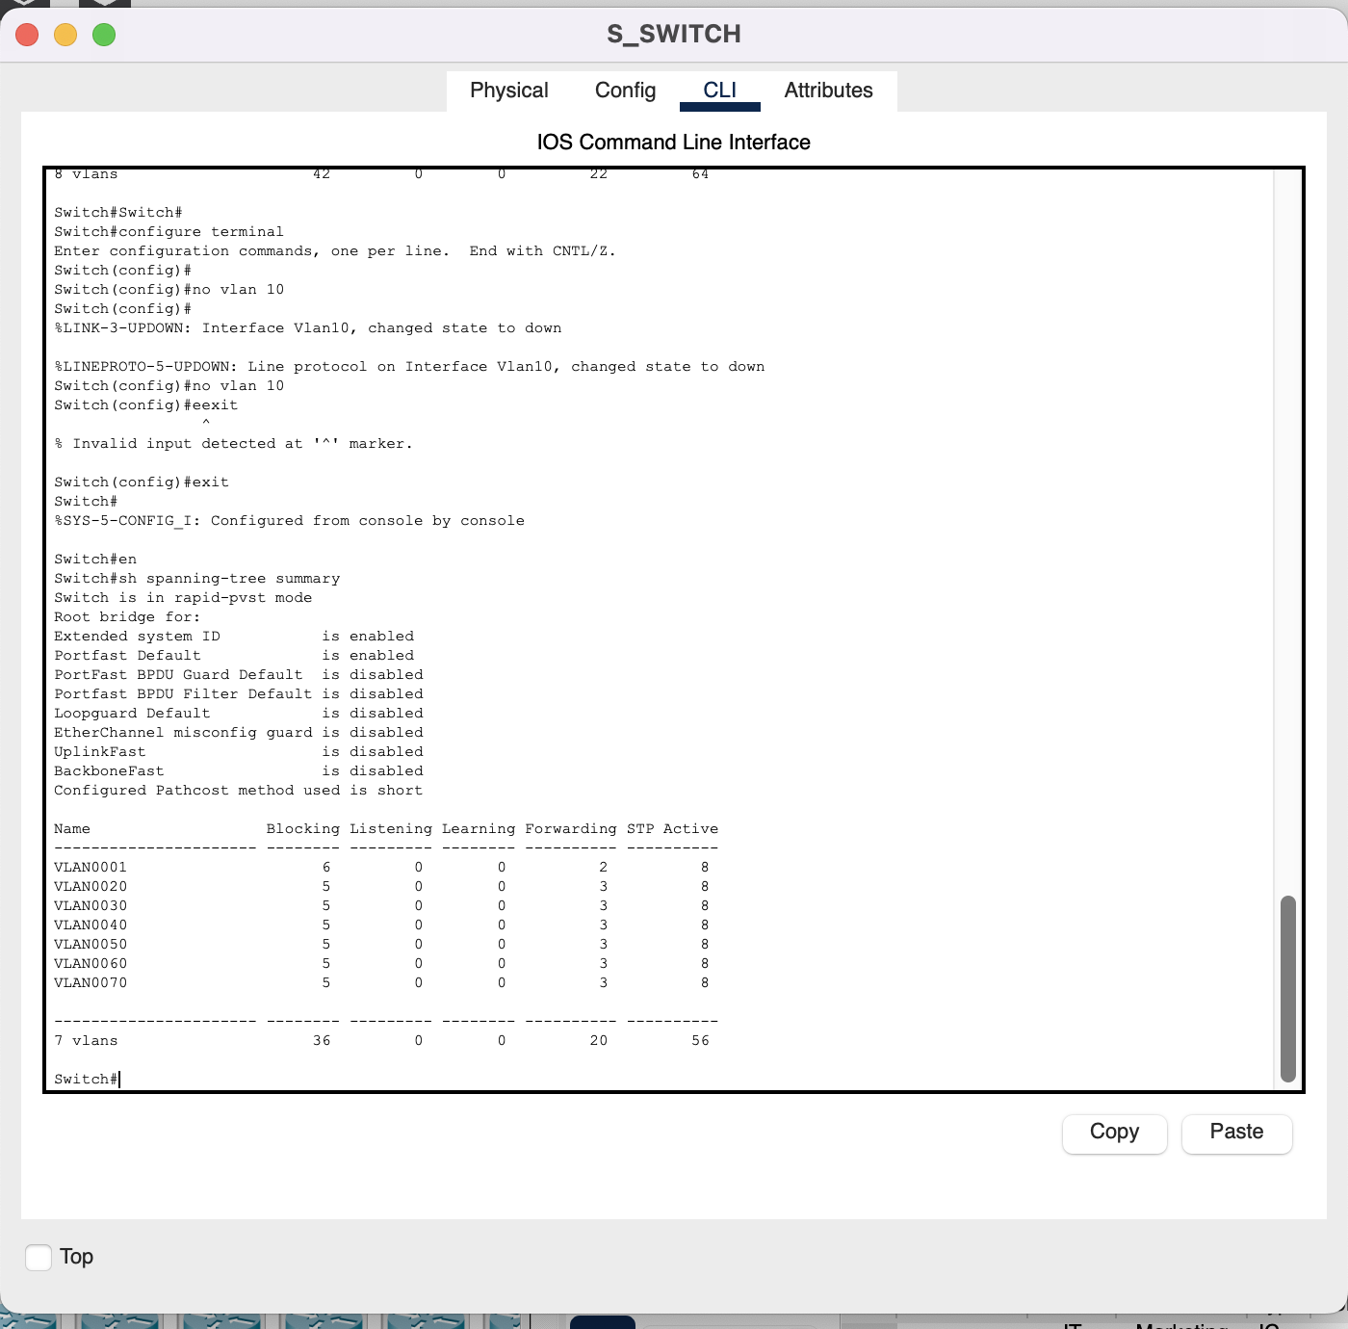

HSRP

Primary Router:

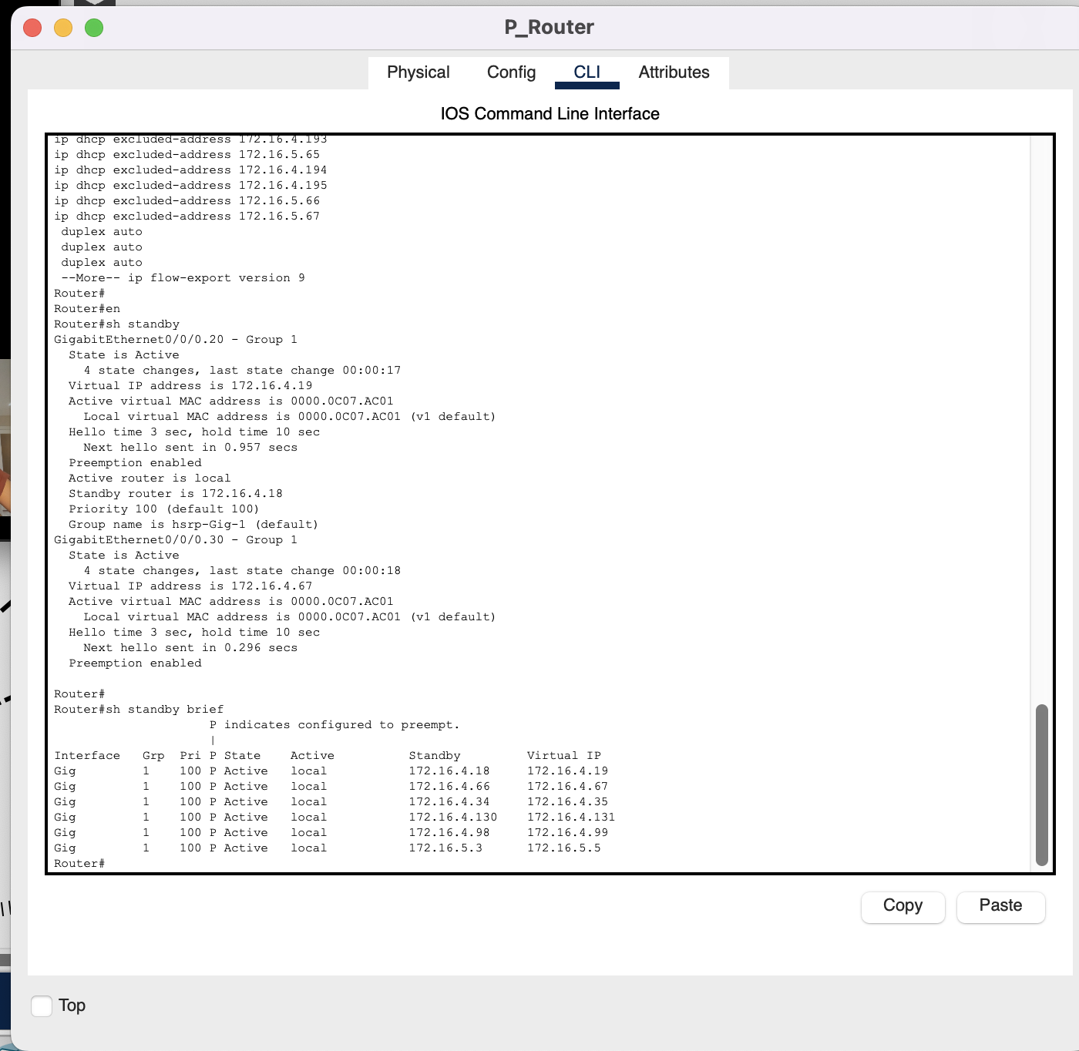

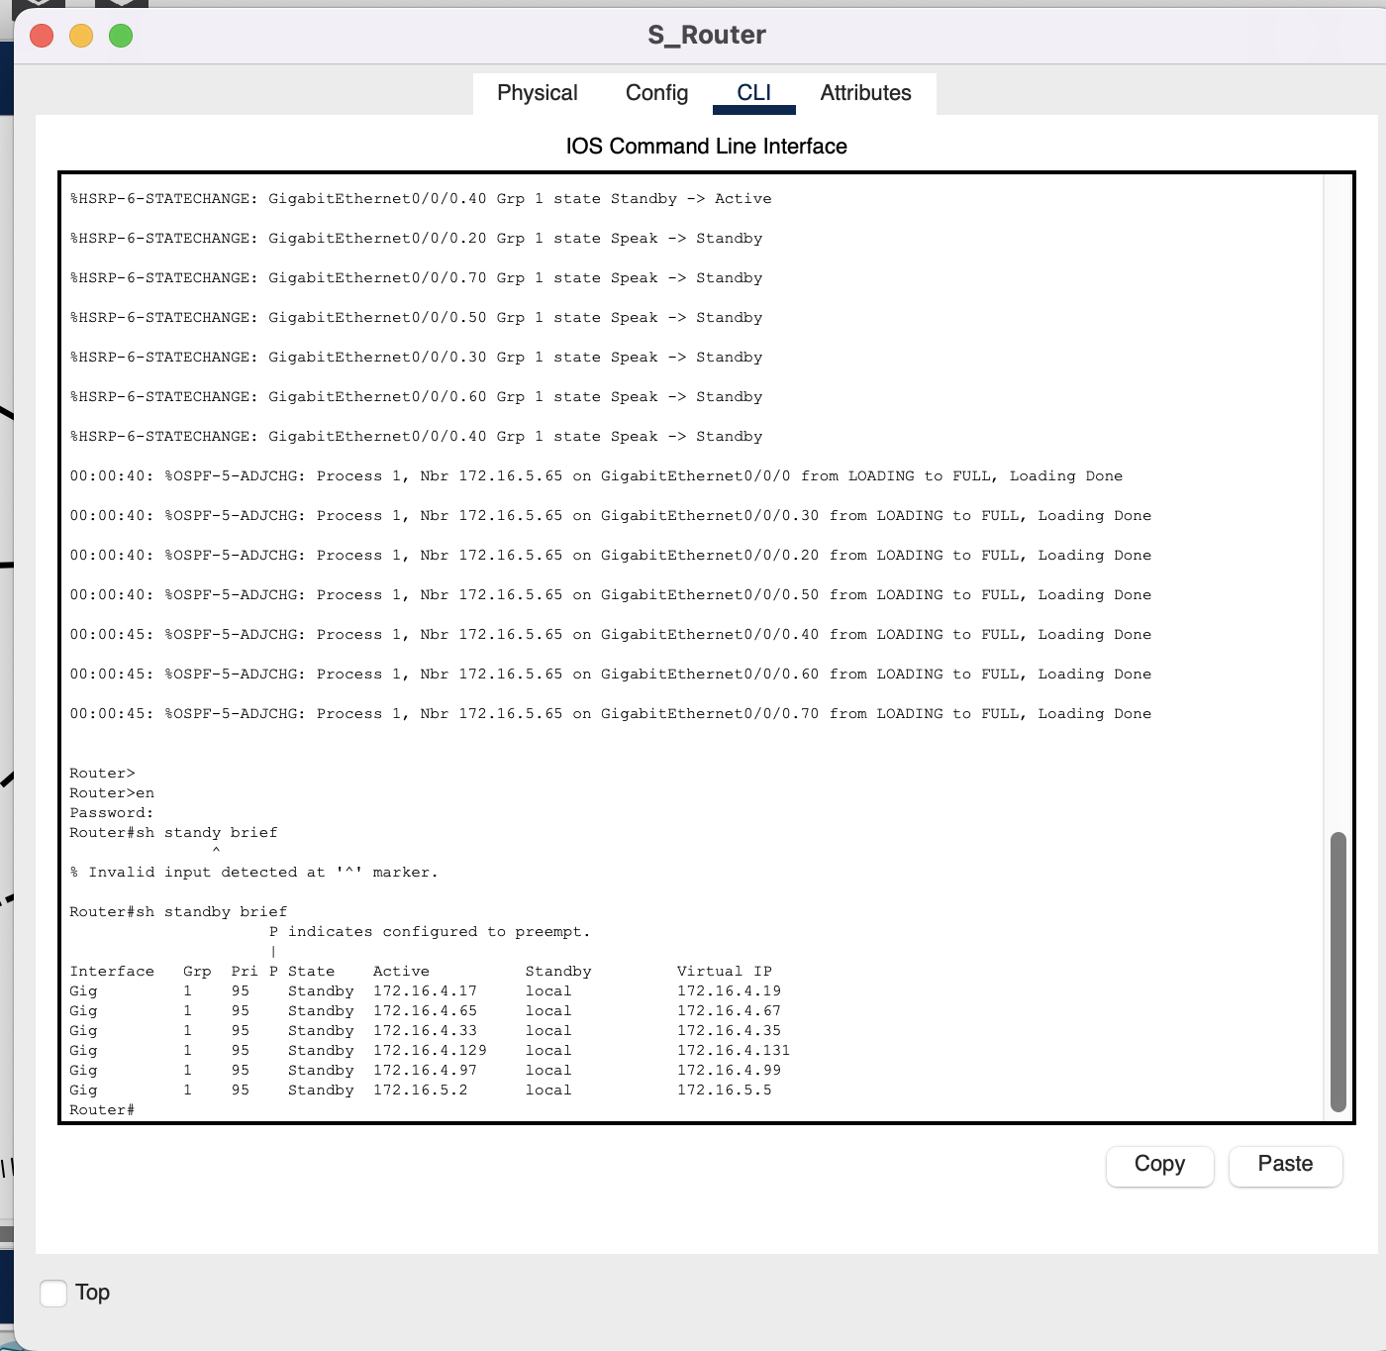
Secondary Router:

VTP

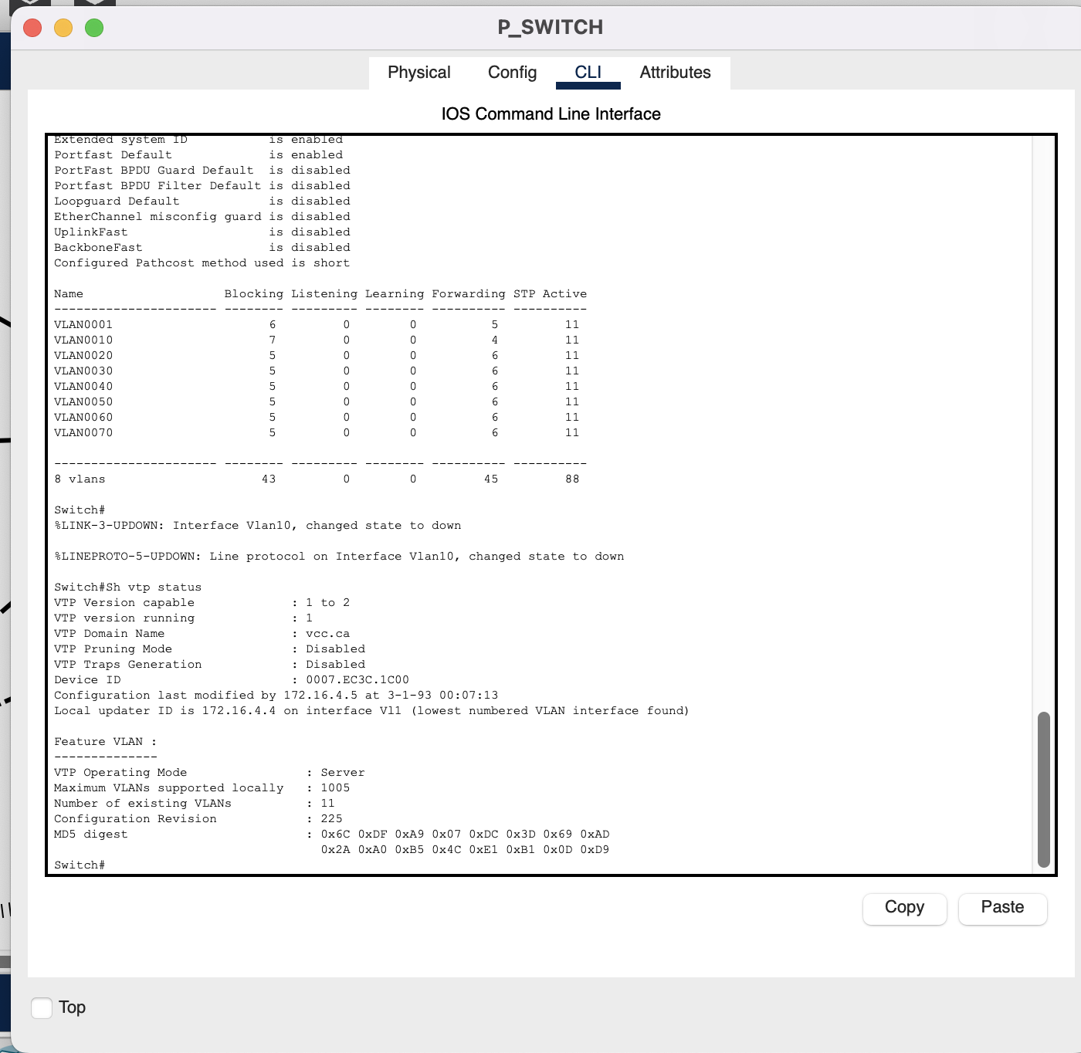
Primary Switch:

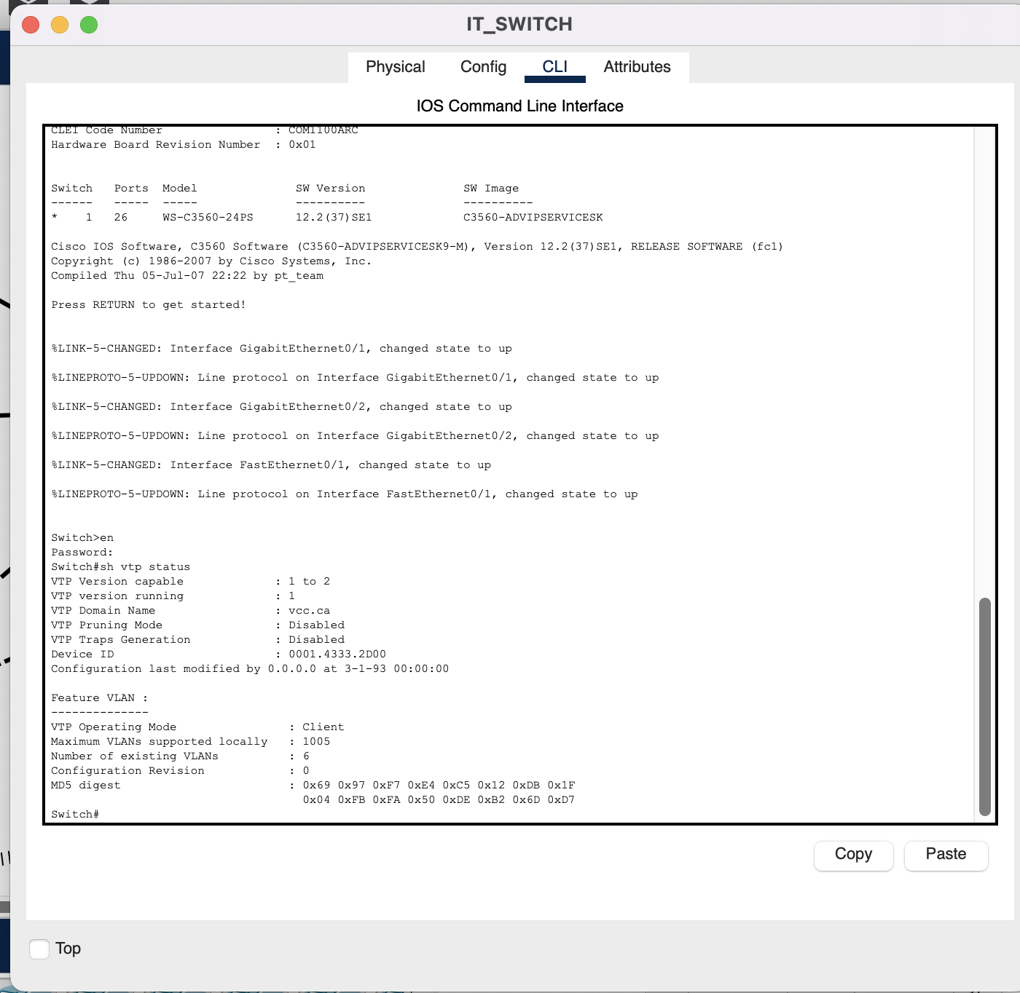
Access Level Switch:

DNS & Webservers

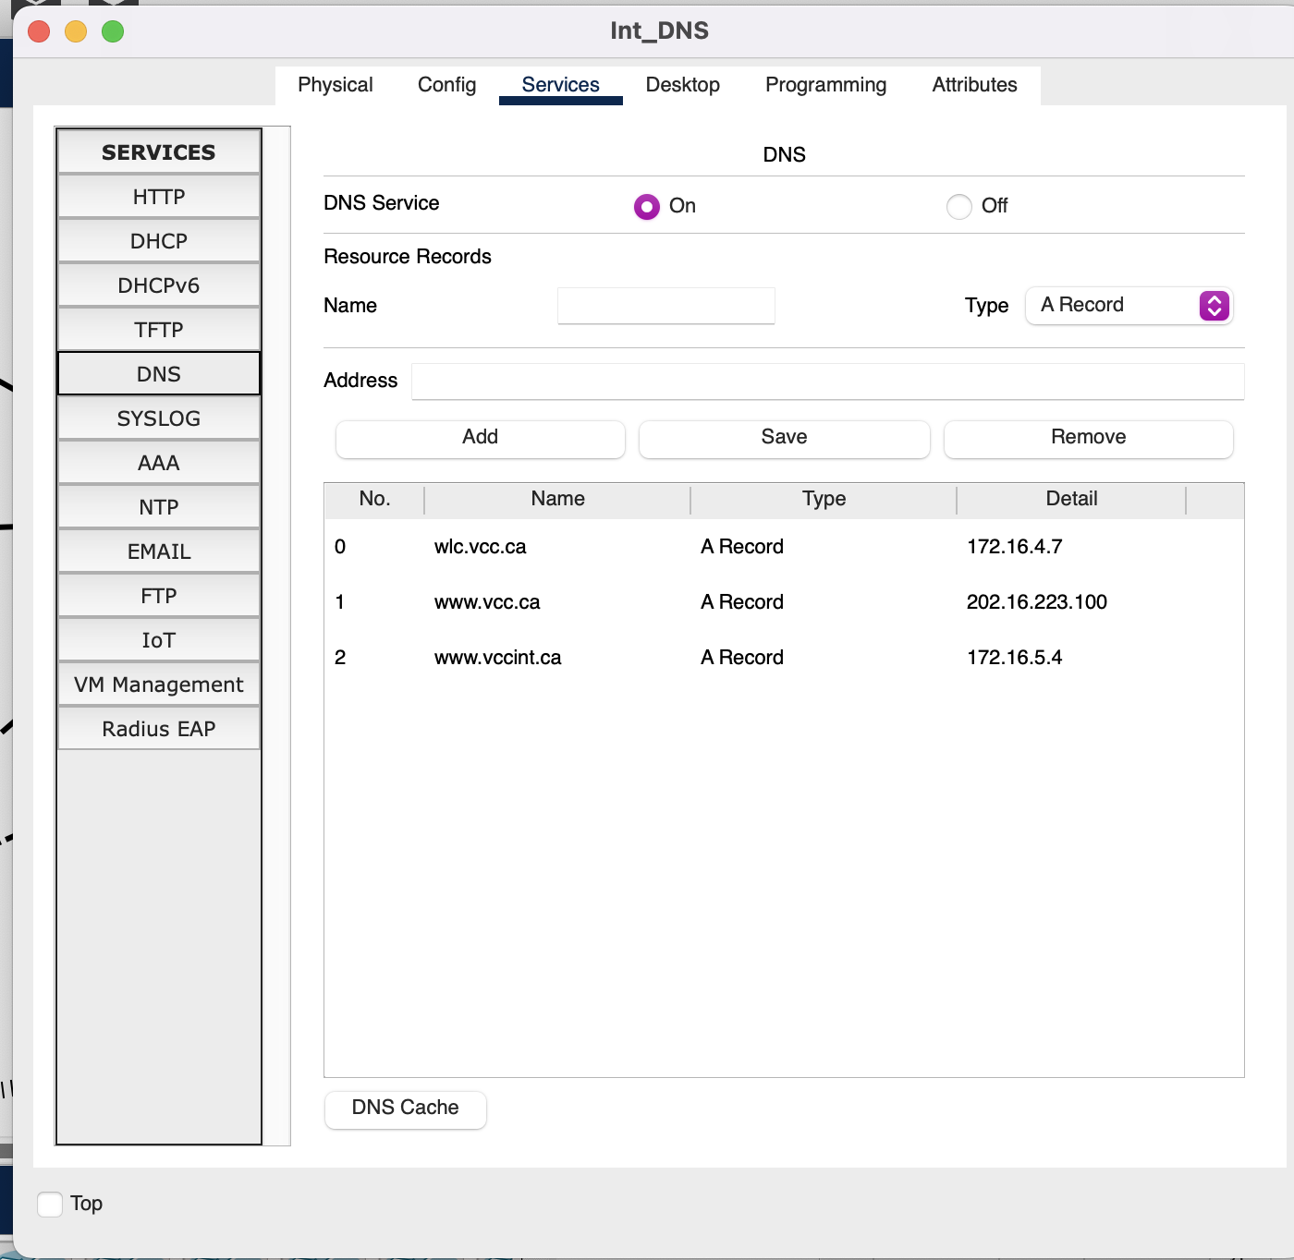
Internal DNS :

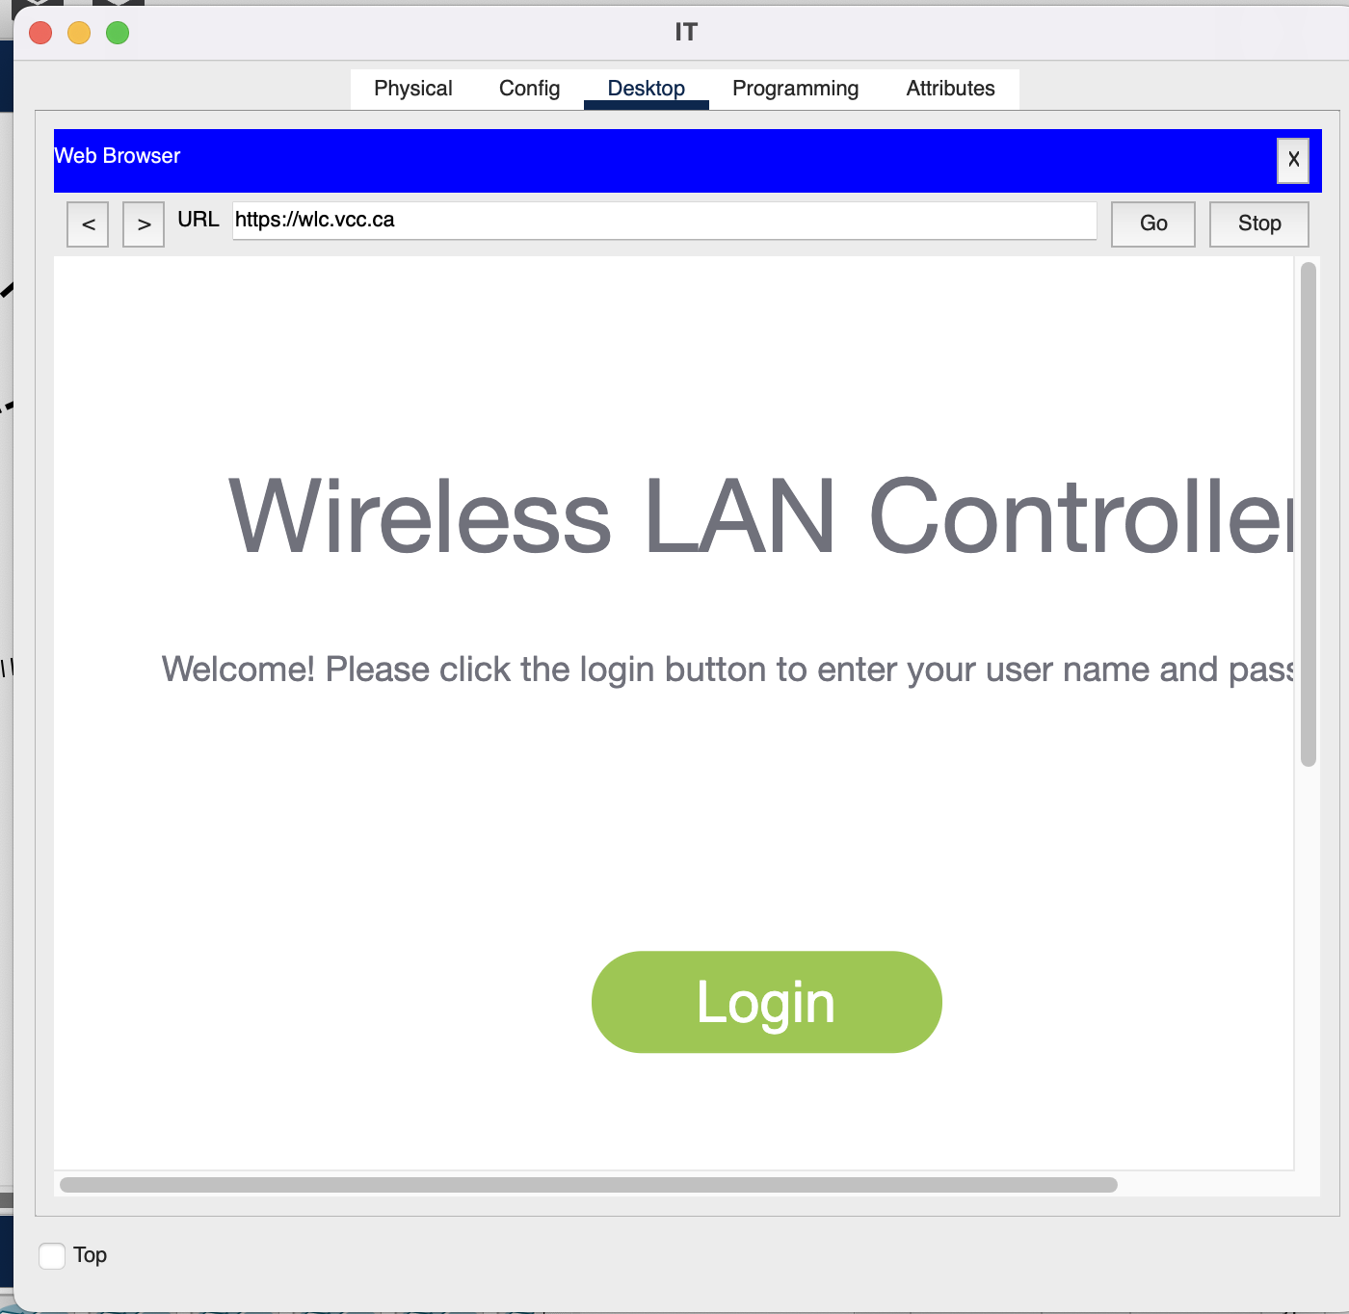

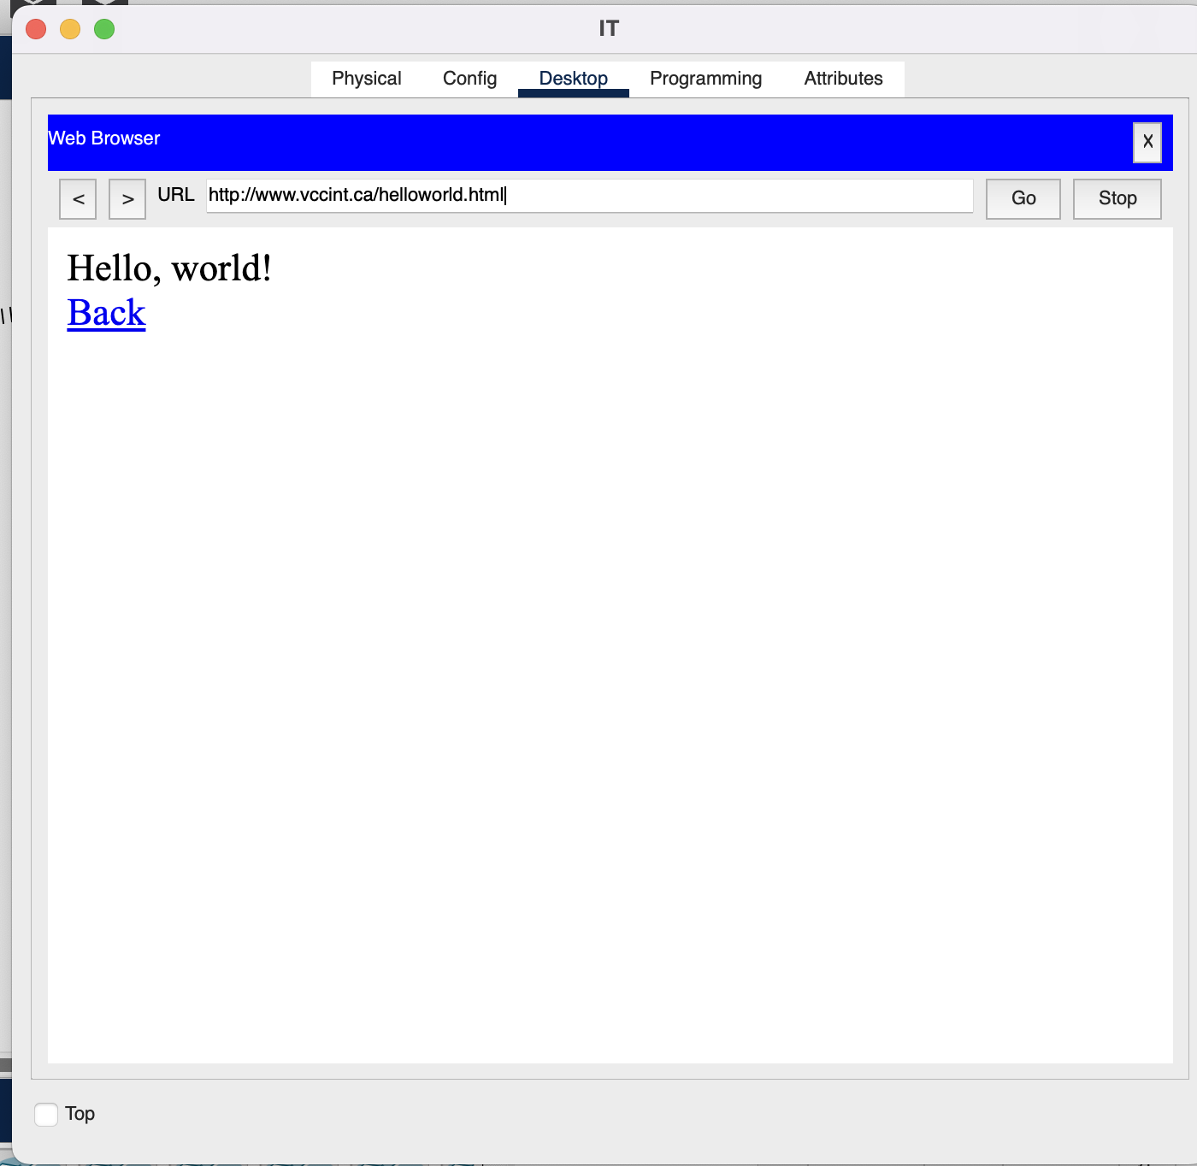

Public DNS:
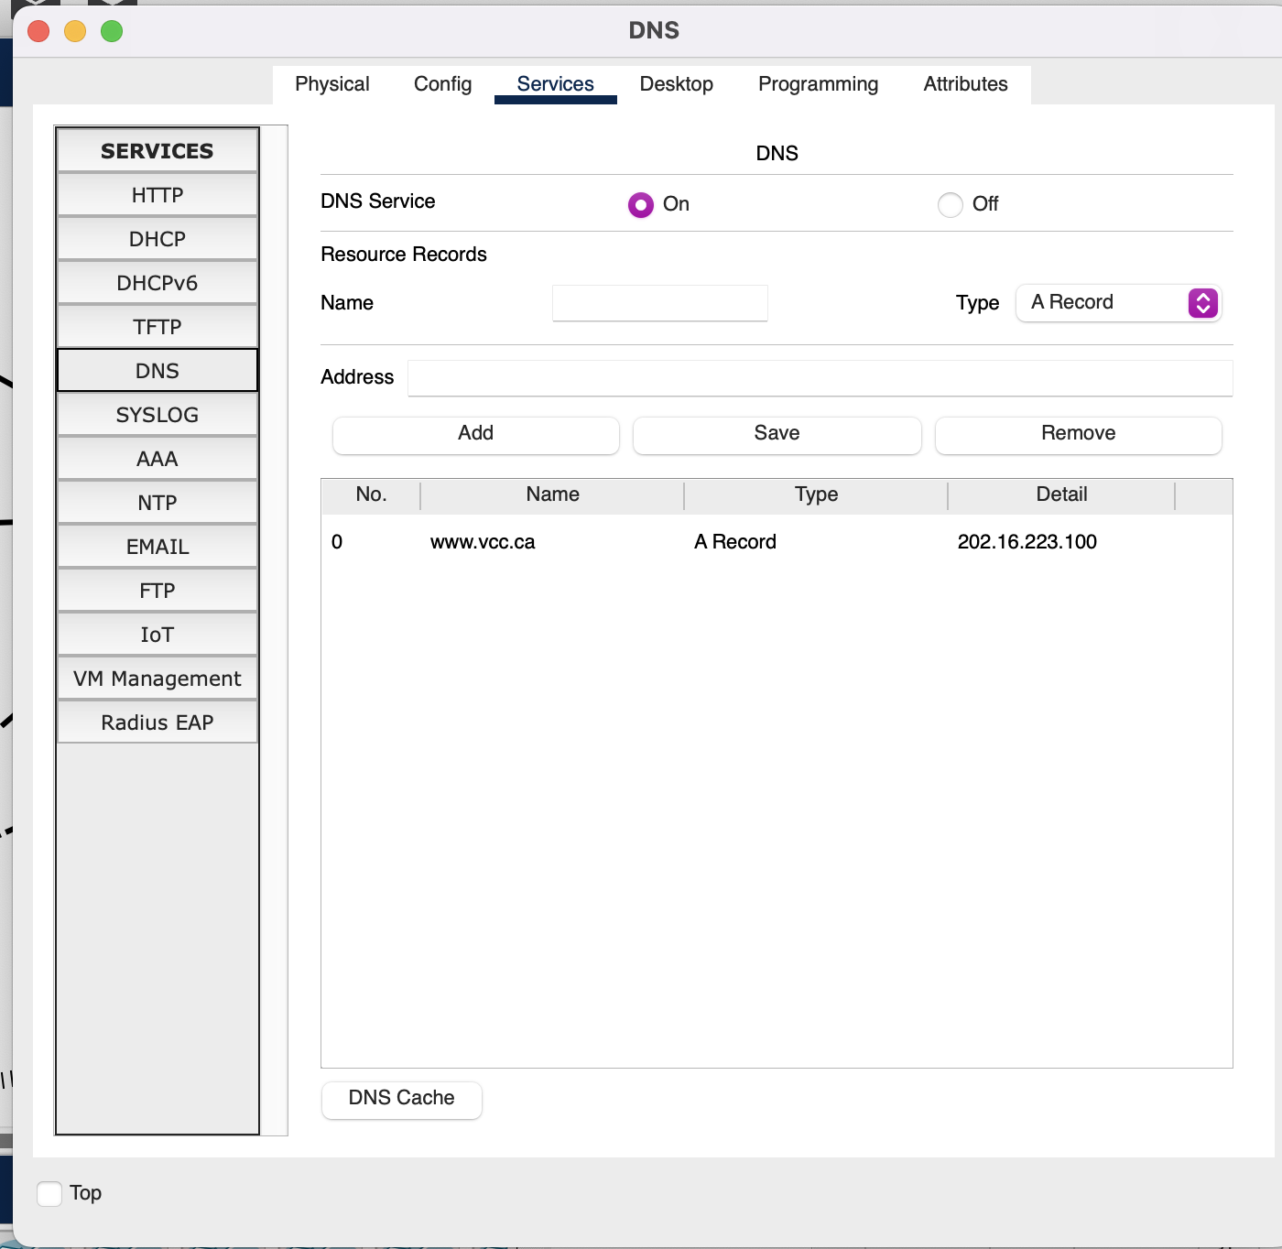

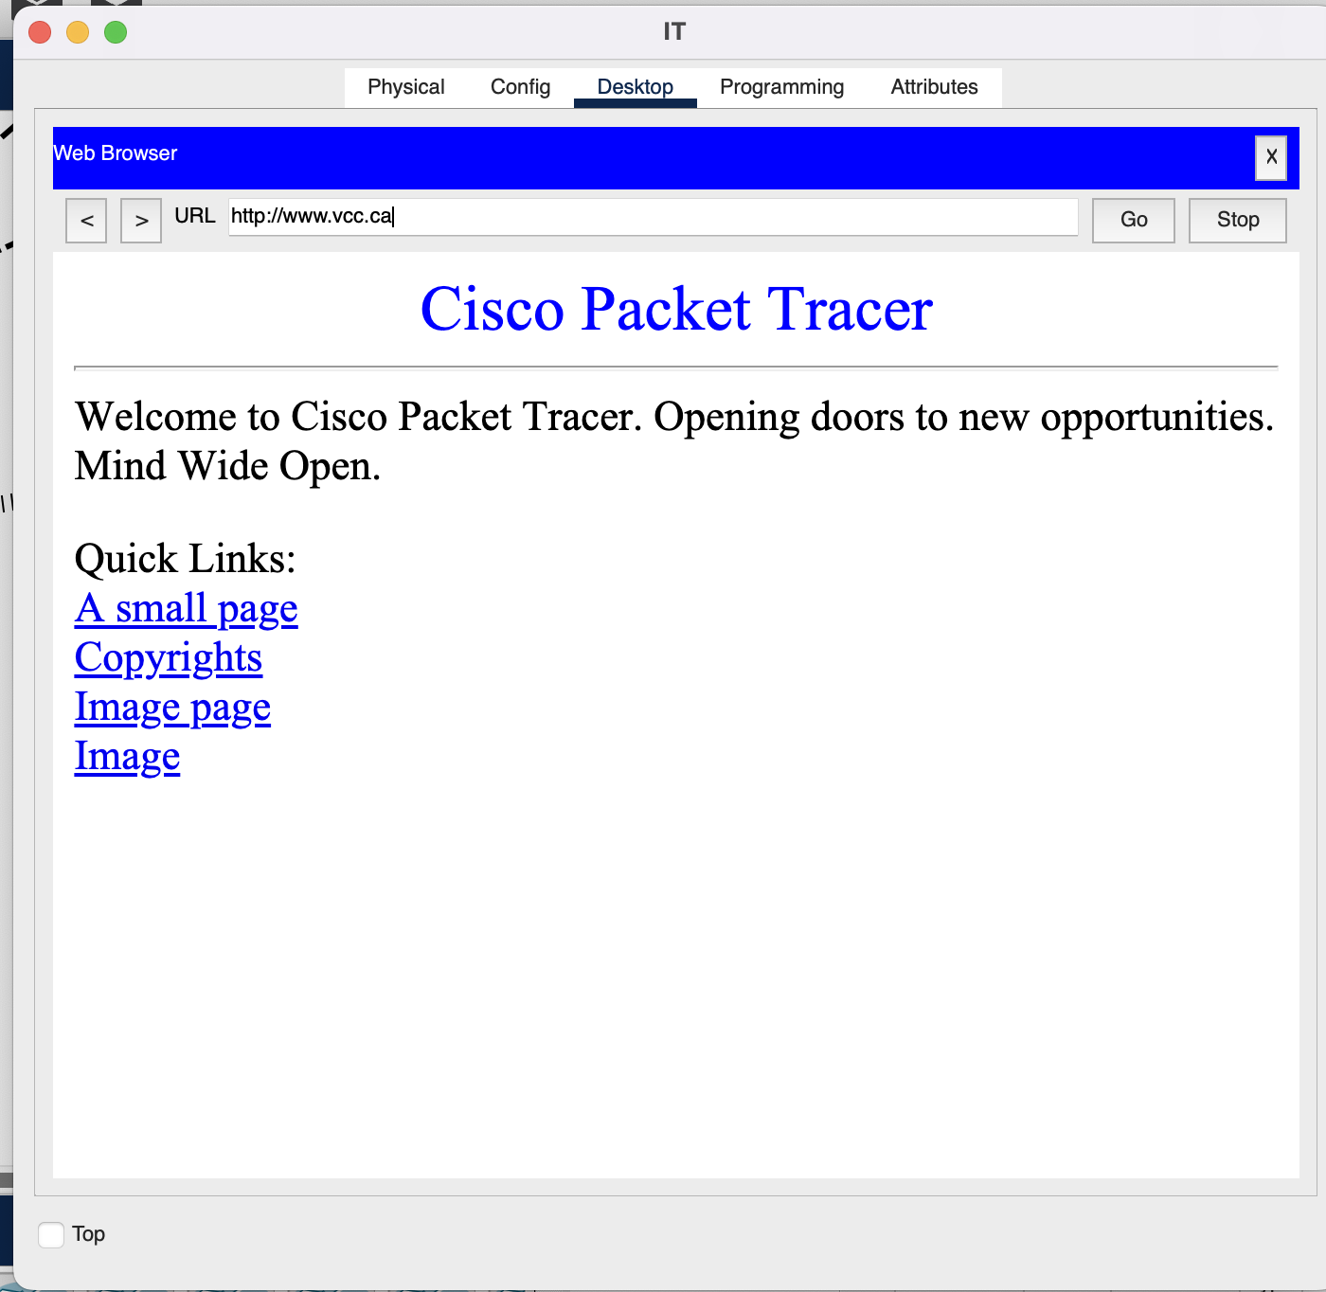

Access List

- access-list 50 permit 172.16.5.65 0.0.0.63. is used to prevent guest from access internal resources .

Access Credentials
Device |  | Password(Secret)
All Routers |  | password@123
All Switches |  | password@123
Device , Wlan | SSID , Username |  | Password
WLC | admin |  | Admin!
Internal Wireless | InternalWifi |  | Admin@123
Guest Wireless | GuestWifi |  | Guestwifi

